## **Cnf-Production-vm's Backup in Portal**

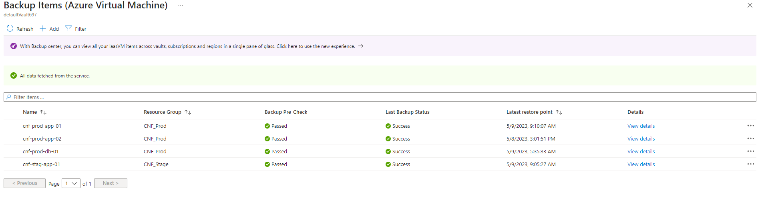

## **Cnf-Production-vm's DR**



 